
YEAR 12 CHEMISTRY - 3ACHE

TEST 2 - 2015

Stoichiometry and Equilibrium

/ 50
Recommended time: 1 hour

Name: _____________________________________________________

Teacher: _____________________________________________________

This test is in two parts.

Part 1: Multiple choice style test consisting of 10 questions.
Each question is worth 1 mark.
Write your answers in the table provided.
Attempt ALL Questions

Part 2: Short and/or Extended Answer questions containing 5 questions worth 40 marks.
Write all answers in the spaces provided.
The marks allocated to each question are shown at the foot of each question.

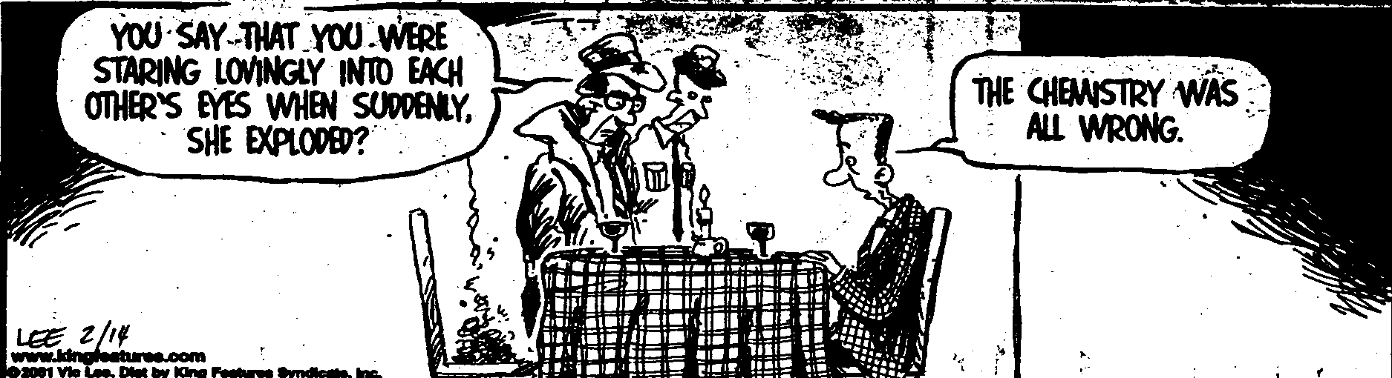

PART 1: MULTIPLE CHOICE (16 marks)

- Consider the following equilibrium equation and expression for a 1.0 mol L⁻¹ solution of oxalic acid:
H₂C₂O_{4(aq)} ⇄ H⁺_{(aq)} + HC₂O₄⁻¹_{(aq)}

K = [H⁺][HC₂O₄⁻¹] = 6.4 x 10⁻⁵ at 25ºC
[H₂C₂O₄]

At equilibrium at 25ºC, which of the following species will be present in the greatest concentration?

  - H⁺_{(aq)}
  - HC₂O₄⁻¹_{(aq)}
  - H₂C₂O_{4(aq)}
  - H⁺_{(aq)}, HC₂O₄⁻¹_{(aq)} and H₂C₂O_{4(aq)} are present in equal concentrations.

- In which of the following reactions will there be an increase in the proportion of products if the volume of the reacting system is reduced ?

  - H_{2(g)} + I_{2(g)} ⇄ 2 HI_{(g)}
  - 2 NO_{2(g)} ⇄ N₂O_{4(g)}
  - 2 SO_{3(g)} ⇄ 2 SO_{2(g)} + O_{2(g)}
  - H₂O_{(g)} + C_{(s)} ⇄ H_{2(g)} + CO_{(g)}

- Assuming equilibrium is reached (at 500ºC and 150kPa) in the reaction:

2CO_{(g)} + O_{2(g)} ⇄ 2CO_{2(g)} ΔH = - 565 kJ

Which one of the following changes will increase the yield of carbon dioxide?

  - raising the temperature to 700ºC and pressure to 200kPa.
  - lowering the temperature to 300ºC and pressure to 100kPa.
  - raising the temperature to 700ºC and lowering the pressure to 100kPa.
  - Lowering the temperature to 300ºC and raising the pressure to 200kPa.

- Water is added to a saturated solution of silver chloride so that its original volume is doubled. More solid silver chloride is added and equilibrium is again established with the solid in contact with the solution.

Which one of the following statements is TRUE?

  - The Ag⁺_{(aq)} concentration will have decreased to half of its original concentration.
  - The Ag⁺_{(aq)} concentration will have doubled.
  - The Ag⁺_{(aq)} concentration will have increased while the Cl⁻_{(aq)} will have decreased.
  - The Ag⁺_{(aq)} concentration will remain the same.
- The potential energy diagram below refers to the reaction
I₂(s) ⇄ I₂(aq)
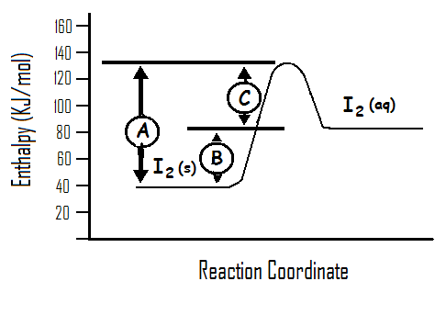
Which of the following statements is FALSE?

  - ‘A’ is the activation energy for the reaction
I₂(s) I₂(aq)

  - ∆H for the forward reaction is positive and has the value ‘B’

  - At equilibrium the rate of reaction I₂(aq) I₂(s) is faster than that
of I₂(s) I₂(aq)

  - An increase in temperature will alter the equilibrium position and increase the solubility of I₂

- For a reversible reaction, catalysts alter

  - The heat of reaction for the forward reaction
  - The size of the equilibrium constant.
  - The time taken for the equilibrium to be established.
  - The nature of the products formed in the forward reaction.

- Which one of the following statements concerning the equilibrium constant (K) for a chemical reaction is FALSE:

  - K indicates the relative proportions of products to reactants at equilibrium.

  - K will alter if the temperature of the system at equilibrium is altered

  - K provides no information about the initial rate of the forward reaction

  - K will alter in value if a change in the pressure occurs in the system at constant temperature, once equilibrium has been re-established.

- Measured at constant temperature, the rates of chemical reactions decrease as the reaction proceeds because:

  - The forward and reverse reaction rates must approach zero as equilibrium is reached.
  - The reactant concentrations decrease with time
  - The fraction of reactant molecules with energies in excess of the activation energy decrease as the reaction proceeds.
  - Absorption of heat by the reaction diminishes the reaction rate.

- Consider the equilibrium:

2ClF₃(g) ⇄ 3F₂(g) + Cl₂(g) ∆ H = negative

For a particular equilibrium mixture, the temperature is lowered and the amount of ClF₃ changes by 0.010mol. The changes occurring would be:

 | ClF₃ | F₂ | Cl₂
a) | Increase by 0.010 mol | Decrease by 0.015 mol | Decrease by 0.005 mol
b) | Increase by 0.010 mol | Decrease by 0.0067 mol | Decrease by 0.020 mol
c) | Decrease by 0.010 mol | Increase by 0.015 mol | Increase by 0.005 mol
d) | Decrease by 0.010 mol | Increase by 0.067 mol | Increase by 0.020 mol

- Doubling the rate of a gas reaction in a closed vessel by raising the temperature from 10ºC to 20ºC can best be attributed to

  - doubling the average kinetic energy of the reactant molecules.
  - doubling the activation energy of the reaction.
  - doubling the average speed of the molecules.
  - doubling the proportion of molecules that possess the necessary activation energy.

END OF MULTIPLE CHOICE QUESTIONS



Kiara College

Year 12 Chemistry Test 2

Multiple-Choice and Short Answer Booklet

Total 50 marks

Name: _____________________________

Teacher: _____________________________

For each question, shade the box to indicate your answer.
Use only a blue or black pen to shade the boxes.

For example, if b is your answer: a b c d

If you make a mistake, place a cross through that square then shade your answer.
Do not erase or use correction fluid.

For example, if b is a mistake and d is your correct answer: a b c d

If you then want to use your first answer b, cross out d and then circle b.

a b c d
Marks will not be deducted for incorrect answers.
No marks will be given if more than one answer is completed for any question.

PART 1:
Questions 1-10 (10 marks)

1 | a b c d
2 | a b c d
3 | a b c d
4 | a b c d
5 | a b c d
6 | a b c d
7 | a b c d
8 | a b c d
9  10 | a b c d  a b c d
PART 2: WRITTEN SECTION (40 marks)

1. Methane and water react to produce carbon monoxide and hydrogen according to the equation:

CH₄(g) + H₂O(g) ⇄ CO(g) + 3 H₂(g) ΔH = +200 kJ mol⁻¹

Assume the reaction is allowed to come to equilibrium at 200^{O}C and a pressure of 150kPa.

Using the terms: INCREASE, DECREASE, NO CHANGE to answer (a), (b) and (c):

- Once the equilibrium has been re-established, how will the VALUE of the equilibrium constant (K) change if:

(i) the volume of the vessel is halved ____________________

(ii) the temperature is raised to 500^{O}C ____________________

- Once the equilibrium has been re-established, what happens to the equilibrium concentration of carbon monoxide if the following changes occur?

- Gaseous water is added to the system ____________________

(ii) The pressure of the reaction vessel is doubled by adding argon gas
(assuming volume and temperature are kept constant) ________________

- The temperature is decreased to 100^{O}C ____________________

- What happens INITIALLY to the rate of the forward reaction if the following changes are made?

- More CO gas is added to the mixture ____________________

- The volume of the container is halved ____________________

(ii) A suitable catalyst is added ____________________ (8 marks)

2. Consider a solution in which the following equilibrium is established:

Br_{2 (aq)} + 2OHˉ _{(aq)} ⇄ OBrˉ_{(aq)} + Brˉ_{(aq)} + H₂O _{(l)} ΔH = +15kJ mol⁻¹

The molecular bromine (Br₂), gives the aqueous solution a reddish brown colour. All the other species present are colourless.

- The tests described in the table below are carried out on separate 5 mL samples of the solution. For each of the tests,
i) describe any observations from when the change is made initially, until equilibrium has been re-established.
ii) In each case, give an explanation for your answer using reaction rate and collision theory, NOT Le Chatelier’s Principle.

 | Observations | Explanation
Test 1:
A small amount of a concentrated solution of bromine is mixed into the solution.

(3 marks)

Test 2:
2 mL of water is added to the solution.

(3 marks)

Test 3:
The solution is heated from room temperature to 60ºC.

(2 marks)

(8 marks)
(b) Write the expression for the equilibrium constant (K) for the reaction. (1 mark)

(c) Sketch graphs of what happens to the rate of the forward and reverse reactions for test 3 (where the temperature was increased to 60ºC), from before the change is made until equilibrium has been re-established at t₁. Clearly indicate which graph represents the forward reaction and which represents the reverse. (2 marks)

Rate of reaction

Test 3 t₁ Time
occurs

3. Part of the contact process for the manufacture of sulfuric acid involves the conversion of sulfur dioxide to sulfur trioxide as shown by the equation:

2SO₂(g) + O₂(g) ⇄ 2SO₃(g) ΔH = -192kJ mol⁻¹

As part of a laboratory study of the process, a container was filled with an equilibrium mixture of SO₂, SO₃ and O₂ in the presence of a catalyst. The container was originally at 450ºC. The container had a fixed volume and was thermally well insulated. Concentrations recorded during the following experiment are shown in the diagram below:

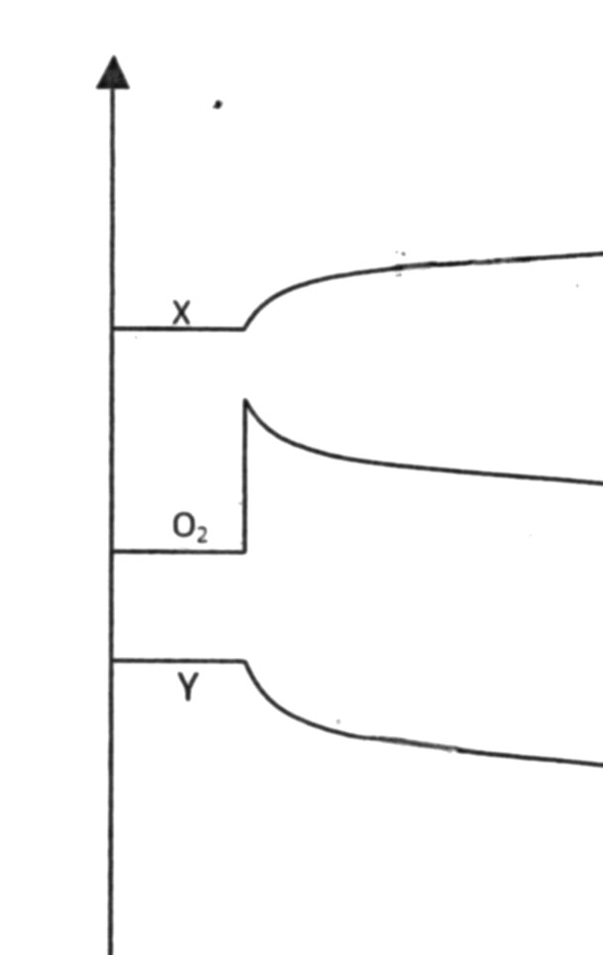

Concentration
molL⁻¹

0 5 10 15 20 25 30 35 40 Time (minutes)

- At t=5 minutes, what change was made to the system? (1 mark)

________________________________________________________________

(b) Which substances in the equilibrium mixture are represented by X and Y?

X is _____________ Y is _____________ (2 marks)

(c) Would the temperature of the mixture increase, decrease or remain the same between 5 and 20 minutes? Explain your reasoning. (2 marks)

_________________________________________________________________________________________________

_________________________________________________________________________________________________

_________________________________________________________________________________________________

(d) At t = 20 minutes, some SO₃ was removed from the container. Continue the graph to represent the changes made to the concentrations of X, Y and O₂ until equilibrium has been re-established at 35 minutes.
(3 marks)

4. Nitroglycerine (C₃H₅(ONO₂)₃) is used in explosives. Its decomposition is shown by the following equation.

4C₃H₅(ONO₂)_{3 (l)} 6N_{2 (g)} + 12CO_{2 (g)} + 10H₂O _{(g)} + O_{2 (g)}

Calculate the total volume of nitrogen gas produced, if 16.60 g of nitroglycerine liquid completely decomposes at 500ºC and at 150 kPa pressure.
(4 marks)

5. 2.120 g of pure sodium carbonate was dissolved in water and the solution added with stirring to 10.0mL of 1.00 molL⁻¹ copper(II) nitrate solution. The resulting precipitate of insoluble copper(II) carbonate was then washed and redissolved in a slight excess of sulfuric acid. After slow evaporation, the resulting copper(II) sulfate was recovered as light blue crystals of the pentahydrate (CuSO₄.5H₂O).

The molecular equations for the above chemical processes are given below.

Na₂CO₃ _{(aq)} + Cu(NO₃)₂ _{(aq)} → 2NaNO_{3 (aq)} + CuCO₃ _{(s)}

CuCO₃ _{(s)} + H₂SO₄ _{(aq)} → CuSO_{4 (aq)} + H₂O _{(l)} + CO_{2 (g)}

- Write the ionic equations for the reaction of:

- Sodium carbonate solution and copper(II) nitrate solution.

___________________________________________________________________

- Solid copper(II) carbonate and sulfuric acid.

___________________________________________________________________
(2 marks)

- Calculate the mass of copper(II) carbonate precipitate formed. (4 marks)

(c) Calculate the mass of copper(II) sulfate-5-water crystals (CuSO₄.5H₂O), assuming complete recovery.
(3 marks)

END OF TEST

